**Vintage Jones Franklin**

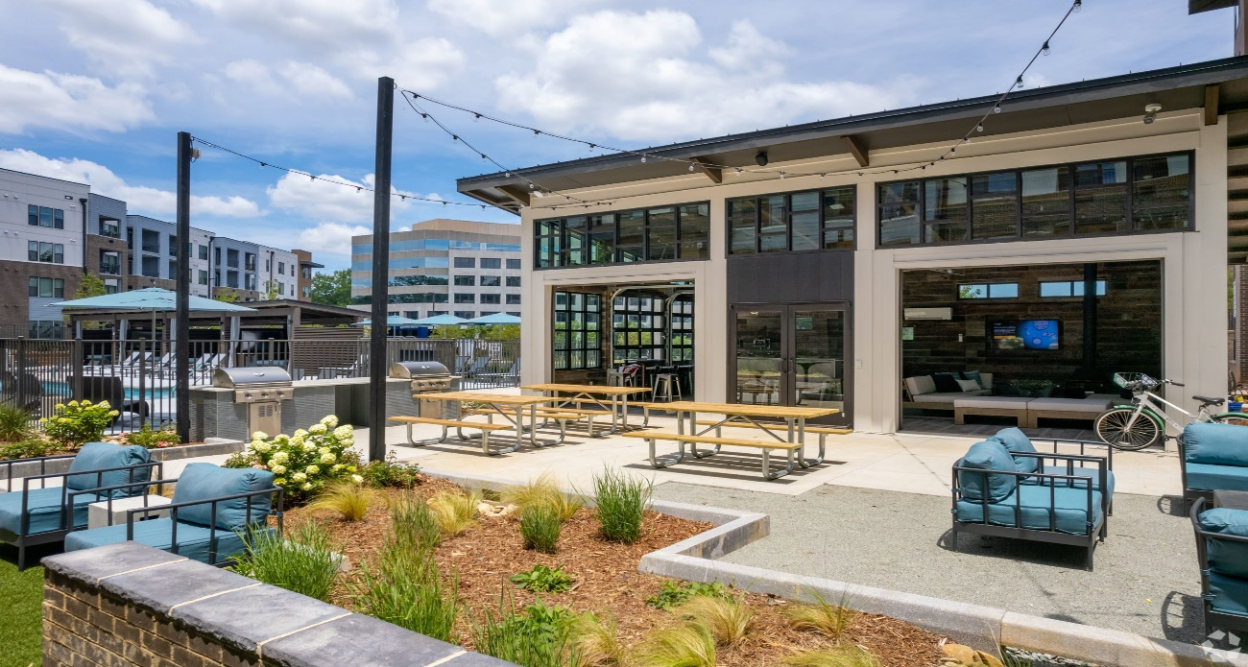

Izzy Andresen, George Booth, Brian Fantaci, and Tamara G Villarroel

Table of Contents

Executive Summary 3

Company Background and Current Environment 3

Problem Analysis 3

Proposed System Objectives 3

Constraints 4

Expected Benefits 4

a. Increase Efficiency 5

b. Increase Marketing 5

c. Enhance Customer Service 5

Context Diagram 6

8. Executive Summary with Narrative and Conclusions ...............................................................6

9. Supplement Specifications (Non-Functional) ............................................................................6

10.Complete Data Flow Diagram Package....................................................................................7

11.Navigation Diagram.................................................................................................................9

12.Hardware and Software Specifications...................................................................................10

13.Program plan showing logic and I/Os....................................................................................10

14.Entity Relationship Diagram..................................................................................................10

# **Executive Summary**

In this report, we will cover the basis of our recommendation to Vintage Jones Franklin by providing a web-based client to help oversee communications to prospective lease holders by generating automated email follow-ups. We will provide information supporting our claim on how the system will run and provide an insight into how this will help the issue of not reaching the targeted occupancy of the apartment complex.

# **Company Background and Current Environment**

Vintage Jones Franklin is a brand-new multi-family residence building in the heart of the Raleigh-Durham triangle. The complex first began construction in the beginning months of 2020 and opened in March of 2022. Since opening, they have had 67% of their units leased and are continually facing issues regarding their CRM system that inhibits them from reaching full occupancy.

The owner of the building is TDK Construction, based out of Murfreesboro, Tennessee and has been a long-proven trusted business in the construction industry. Vintage Jones Franklin is managed by Bell Partners Inc. That has a proven track record of providing high quality multifamily asset management services to fully support the economic drive of the builders.

# **Problem Analysis**

Problem: Our client, which is the Vintage Jones Franklin apartment building, is looking to increase its occupancy numbers by having an automated email follow-up system to help them spend less time having to do each one manually.

Cause: The cause of this is that the system that they use currently to respond to people who have come on tours does not have the option.

Challenges: Some challenges that we could have, that our client might want to keep the system that they already use since they have been using it for a while now and could affect some things since they would have to learn to use a new system.

We will be using a business process improvement (BPI) to take what they already have and make a system that would be like what they are using now and add automatic follow-up emails to potentially new customers.

# **Proposed System Objectives**

The system we have chosen to propose for Vintage Jones Franklin apartments is a web-based email automation system that will be created and hosted on WordPress. Using WordPress will give us everything we need to create the system, things like database access which we will be using to get contact information and WordPress hosts the server that will be needed for the website. This system will automatically send follow up emails to people who have submitted their email through a tour of the apartment building. Having a system like this will help improve the percentage of people living in apartments. This will allow a quicker response time to follow-up emails to hopefully secure new clients.

# **Constraints**

Developing an application can be a complex and challenging process, and there are several constraints that developers must overcome to create a successful product. Some of the most common constraints include time, budget, resources, and technology limitations. In this essay, we can discuss these constraints in detail and how they can impact the development process and completion of the project.

One of the primary constraints in application development is time. Many developers are under tight deadlines and must work quickly to deliver the application within a specified timeframe. This fact can be especially challenging when developing complex applications that require significant resources and expertise. To meet these deadlines, developers must carefully plan their work and prioritize tasks to ensure that the most essential elements of the application are completed on time.

Another constraint is budget. Many developers are limited by the budget available for the project, which can impact the quality of the final product. For example, if the budget is limited, developers may have to make compromises in terms of features or the user interface, which can negatively impact the user experience. To overcome this constraint, developers must work closely with stakeholders to understand their requirements and find ways to balance the cost of development with the quality of the final product.

A third constraint is the availability of resources, such as personnel and technology. Developers may not have access to the right people or technology needed to build the application, which can slow down the development process and impact the quality of the final product. To overcome this constraint, developers must be proactive in sourcing the resources they need, such as working with outsourcing partners or investing in modern technology.

Finally, technology limitations can also be a constraint in application development. For example, the technology used in the development process may not be able to handle the application's demands, or it may not be well suited to the target audience's needs. In conclusion, the development of an application is a complex process that is subject to many constraints, including time, budget, resources, and technology limitations. To overcome these constraints, developers must be proactive, innovative, and flexible, working closely with stakeholders to balance the needs of the project with the available resources. With careful planning and a commitment to quality, developers can overcome these constraints and deliver successful applications that meet the needs of their users.

# **Expected Benefits**

The issue that is keeping Vintage Jones Franklin from reaching a higher leasing occupancy is that their CRM system is inefficient. Team 11 is proposing to enhance the automation response for new and old residents, managers, and employees. Right now, managers and employees of Vintage Jones Franklin must type up individual emails to send to residents which takes a lot of time out of an employee's days.

## **Increase Efficiency**

There would be a great level of increased efficiency for everyone involved if responses became automated. The managers and employees of Vintage Jones Franklin would have to use up less time by being able to send mass emails to residents, instead of individually emailing each one. Residents would also benefit from this due to a faster response rate from the leasing office, which would make living there a better experience.

## **Increase Marketing**

This new feature of enhanced automation responses would be able to be marketed as another reason for people to sign a lease with Vintage Jones Franklin. Timely communication with residents will make them more likely to want to resign due to being able to get their inquiries answered quickly, no one wants to live somewhere where it takes days to receive a response especially if the matter is urgent. The complex would also be able to gain new residents because if someone takes a tour or investigates leasing, the CRM system would automatically send a follow up email with all the necessary contact information if they do choose to proceed with the leasing process.

## **Enhance Customer Service**

By gaining increased automation, Vintage Jones Franklin will be able to provide enhanced customer service to their residents due to timely response rates. Whether it be a billing, maintenance, or miscellaneous issue residents will always be in direct communication with complex management and employees. Many apartment complexes struggle with recognition of receiving residents’ inquiries and with our proposal we hope to increase resident retainment for the complex, as well as simplify the daily duties for those who work there.

# **Context Diagram**

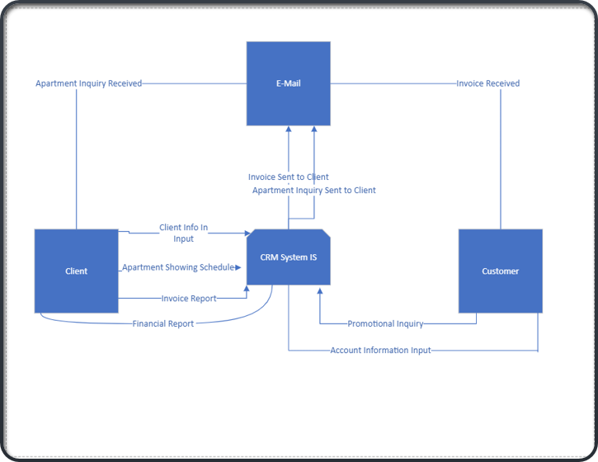

**Use case Diagram**

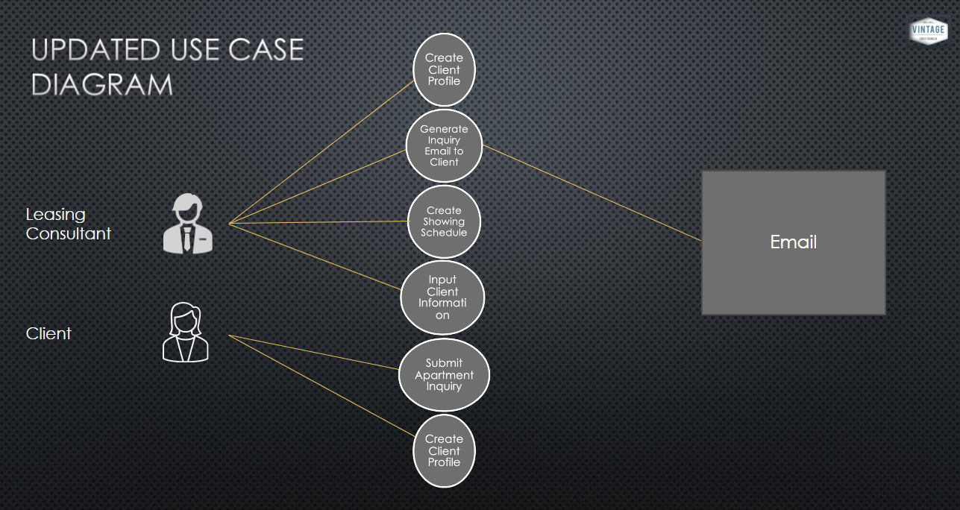

**Section 2 Executive Summary with Narrative and Conclusions**

During section two analysis, we dive deep into the system's non-functional requirements and ensure that all use case diagrams are correct and valid within the scope of work. We have updated all documentation to support the progress that we have made

Throughout this section, we have gained the necessary knowledge to move forward in the project.

**Supplement Specifications (Non-Functional)**

Operational

* System will be supported by any web browser such as Chrome, Firefox, Internet explorer, and Safari
* System will be usable on iPhones and Android phones
* System will be able to create and send emails

Performance

* System should take 30 seconds to process data submitted
* System will send email within 1 hour of submissions
* System will be able to store 2 GBs of data
* System should update status if they have been emailed or not.
* System can support 5 people using at the same time

Security

* System will keep peoples contact information safe and only accessible to staff
* Staff can only access the system

Privacy

* System will follow the privacy and information protection rights

Language And Cultural

* System will use English

**Section 3 Executive Summary with Narrative and Conclusion**

During this section we completed a deep dive within the data flow diagrams Level 0-1. This data flow is a path for data to move from one part of the information system to another. A data flow diagram represents a single data element such the Customer and Client a set of data elements or data structures. The diagrams are most often used to visualize data in a business information system. The data is represented using the system set of inputs and outputs.

**Complete Data Flow Diagram Package**

Level 0

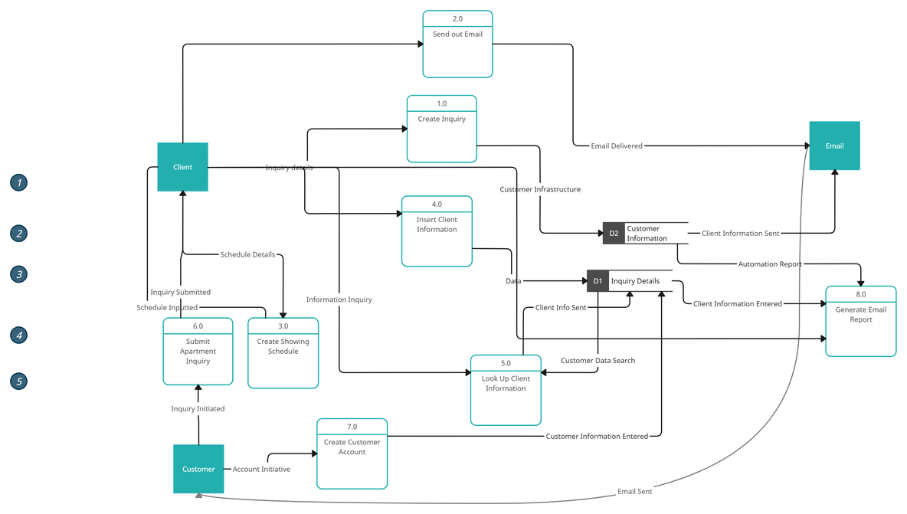

Level 1

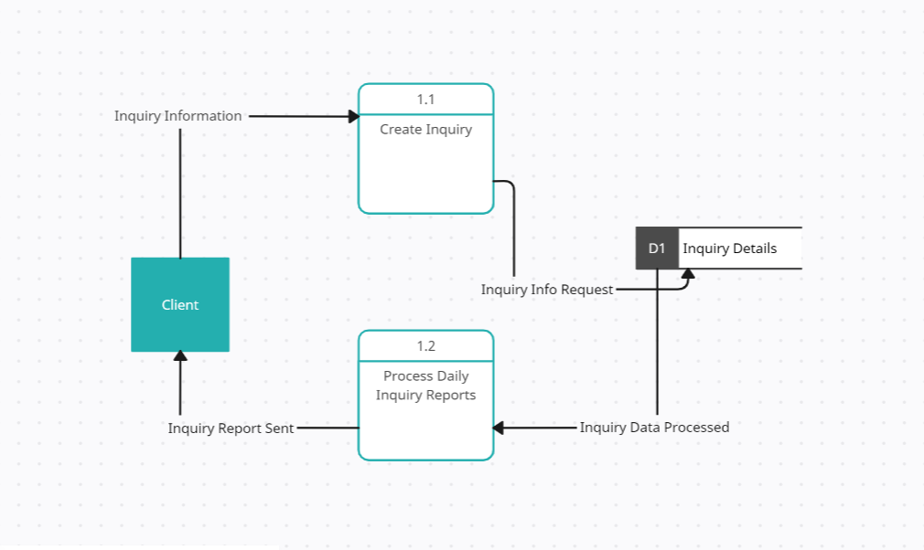

**Navigation Diagram**

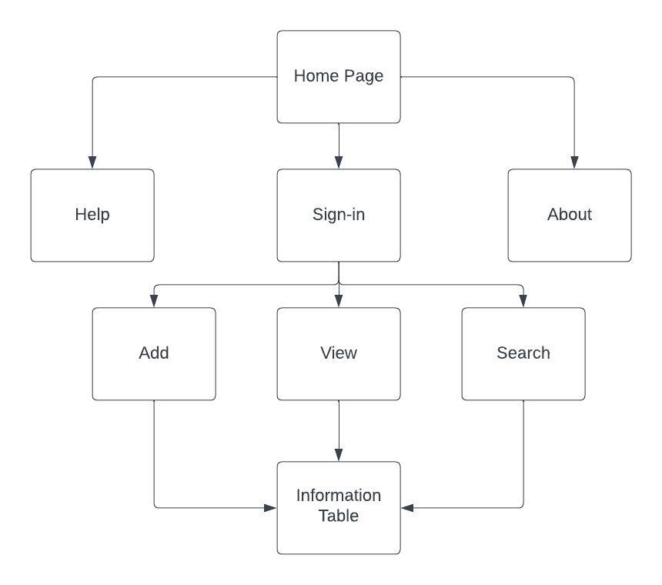

**Hardware and Software Specifications**

|  |  |  |  |  |
| --- | --- | --- | --- | --- |
|  | Standard Client | Standard Web server | Content Management System | Standard Base |
| Operating System | Windows | Windows | Windows | Windows |
| Special Software | Wordpress | Wordpress | Wordpress | Microsoft access |
| Hardware | Dell Desktop | Dell Desktop | Dell Desktop | Dell Desktop |
| Network | Wifi | Wifi | Wifi | Wifi |

**Program plan showing logic and I/Os**

|  |  |  |
| --- | --- | --- |
| Inputs | Processes | Outputs |
| User will generate guest card | Website will add guest to database | Guest will now be viewable by employees |
| Employee generates  automated follow ups | Website will define time increments to send pre-determined follow up emails | Guest will receive automated follow-ups to increase total occupancy percentages |

|  |  |  |
| --- | --- | --- |
| **Input** | **Processing** | **Output** |

**Entity Relationship Diagram**

